POWER HOUSE RECORDS (Germany) PRESENTS: Power House 01 [PWR001]

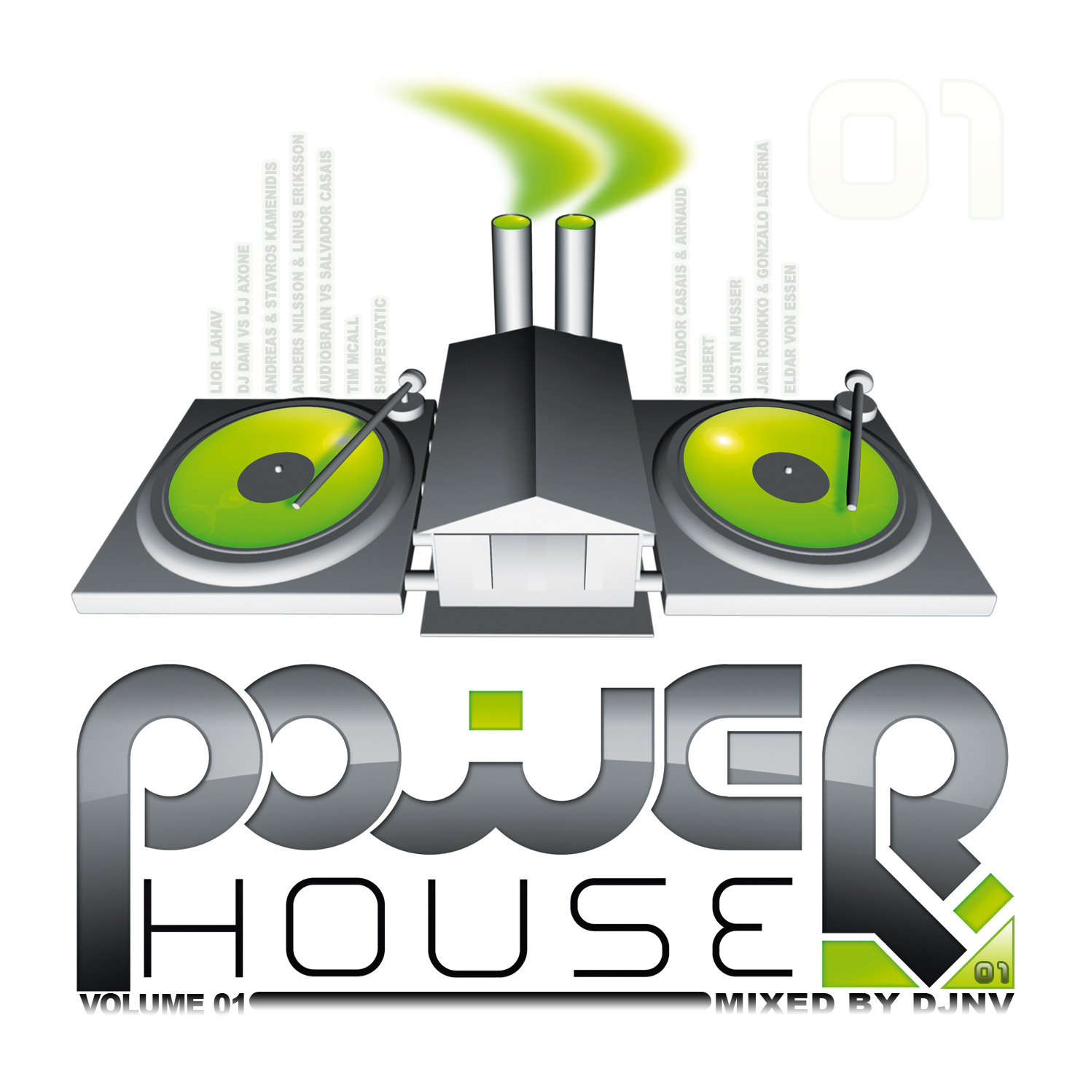 |  | RELEASE NOTES  Power House Volume 01 is the full power progressive hard house dance music that your mother warned you about. Its gonna make you grind and howl and act like an animal cause that’s what its all about! DJNV takes it to the next level as he delivers 11 soul shaping infinite voyages into ecstatic pleasure and bliss! One by one you are treated to the top shelf gems, un-released and/or rare delicacies and crazed funktastic groin throbbing hits by international lead players as well as tons of brand new talent spanking new and ready for the lime light! Much of the music you hear is culled from hard to find albums and out of print vinyl now fully mastered and ready to blast the dance floor. This full power psy style hard-house and techno trance is what you have been waiting for to start pumpin up your party. The CD version is presented mixed (but not too mixed) so both fans and DJs both can use this key tool to turn any gathering into a legendary event! DJNV started spinning and producing electronic dance music since 97 but got started making acid techno house as early as 1989 using a K-2000 and a Mac Quadra 900. Early collaborations with such innovators as Young American Primitive, Entrancing Iris, Nick Philip, Dr. Paradise and other key figures help to define his style and artistic sensibilities at the front lines of the dance music underground scene. Since then he has produced over 50 full length compilation CDs featuring his own and countless other DJ/Producers cutting edge beats. His Dj sets have been demanded across the globe for over 10 years and his reputation has been growing since the late 90s as a leading hard dance and acid trance innovator. Recently the sound has been enhanced by the bloom of cross genre EDM production techniques that continue to push the edges of what is sonically possible. Power House Records Specializes in Hard Dance, NRG, and Acid Techno / Hard House “mash-ups”, expect to see innovative and cutting edge releases pumping out of this super blasting EDM label from Germany. Power House Records produces releases on Vinyl, Digital EPs, DJ mix CDs, and exclusive digital singles. PHR (Power House Records) has a world wide distribution network is most known for its white label releases that have sold like hot cakes every time they surface. The world is ready for house music with more power and a special European twist to give it new life. Power House Records is this new blood to PUMP IT UP!  Artist Profile:  DJNV started spinning and producing electronic dance music since 97 but got started making acid techno house as early as 1989 using a K-2000 and a Mac Quadra 900. Early collaborations with such innovators as Young American Primitive, Entrancing Iris, Nick Philip, Dr. Paradise and other key figures help to define his style and artistic sensibilities at the front lines of the dance music underground scene. Since then he has produced over 50 full length compilation CDs featuring his own and countless other DJ/Producers cutting edge beats. His Dj sets have been demanded across the globe for over 10 years and his reputation has been growing since the late 90s as a leading hard dance and acid trance innovator. Recently the sound has been enhanced by the bloom of cross genre EDM production techniques that continue to push the edges of what is sonically possible.  Label Profile:  Power House Records Specializing in Hard Dance, NRG, and Acid Techno / Hard House “mash-ups”, expect to see innovative and cutting edge releases pumping out of this super blasting EDM label from Germany. Power House Records produces releases on Vinyl, Digital EPs, DJ mix CDs, and exclusive digital singles. PHR (Power House Records) has a world wide distribution network is most known for its white label releases that have sold like hot cakes every time they surface. The world is ready for house music with more power and a special European twist to give it new life. Power House Records is this new blood to PUMP IT UP! More info coming soon.
Title: | Power House 01
Artist: | v/a Mixed by DJNV
Label: | Power House Records
Catalogue: | Pwrcd001
Format: | Jewel Case 4 panel CD
Barcode: | 881034378316
Release: | July 2009
TRACK LIST

01 - Lior Lahav (aka Solar System)-Fire
02 - DJ Dam (aka TeTuna) vs DJ Axone-Sheitan
03 - Andreas and Stavros Kamenidis (aka Predators)-Nasty Tech
04 - Anders Nilsson & Linus Eriksson (aka Andromeda)-Un-Stream-able
05 - Audiobrain vs Salvador Casais (aka Kinesis)-Defending Freedom
06 - Tim Mcall (aka Jirah)-Nice Bytes
07 - Shapestatic (aka Lost Baba & The Bastard)-Headroom
08 - Salvador Casais & Arnaud Hubert (aka Crystal Network)-Particles
09 - Dustin Musser (aka Frost Raven)-Tabula Rasa
10 - Jari Ronkko and Gonzalo Laserna (aka Sonitus Maku)-Unsane Visions
11 - Eldar von Essen (aka Phase Phour)-Flowing Away

CREDITS
Mastered by R. Dubois @ Geomagnetic Rec, San Francisco
Artwork by Jose Luis Razo, Guadalajara MX
Distribution by Arabesque UK / File Rec - Sony Japan
(p) and © Power House Records, Germany distribution and publishing by Geomagnetic.tv
www.geomagnetic.tv
info@geomagnetic.tv



